A000-Afr-Gabon-Ambete-Statue-Early 20th c

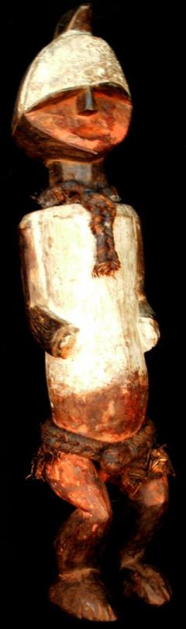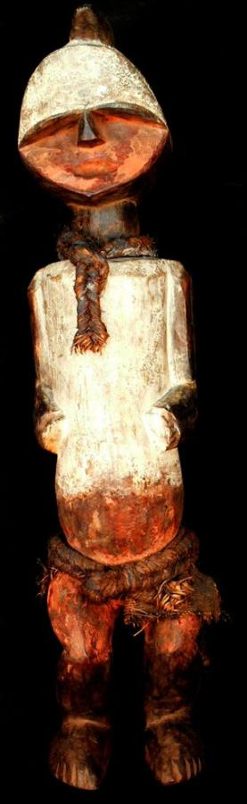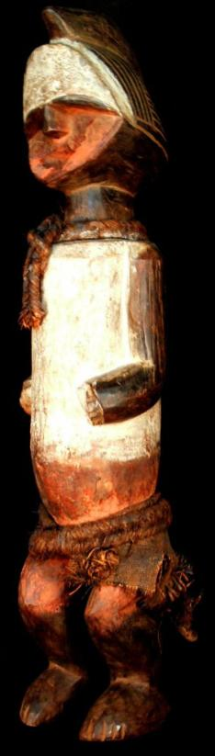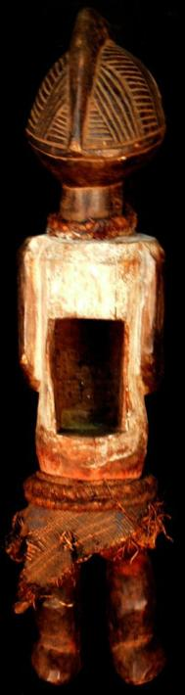

Afr-Gabon-Ambete-Statue-Early 20th c

Case No.: 6

**Accession No.**

**Formal Label:** Afr-Gabon-Ambete-Statue-Early 20th c

**Display Description:**

The Ambete (Mbete, Mbede, Mbete and Mbeti) claimed a Kota origin and live in Gabon and also in the Democratic Republic of Congo. Since these peoples are hunter-gatherers, their locations have, until recently, been constatly shifting so that thier history is complex and difficult to disentangle. However, their culture is fairly well known: secret societies were numerous and powerful, their political organization was with the local tribal unit, and ancestor worship was widely practiced. The current statue is probably an ancestral hunter who had played an important role in tribal life whose relics (of long bones) were placed within its dorsal, rectangular cavity to energize the spirit within the statue.  
  
The faces of these Mbete statues show a prominent forehead overhanging a flat receding face with a rectangular mouth   
and broadly carved features. The forehead may be related to the concept that the cranium was the seat of the being of the individual and so deserved special emphasis. The arms are close to a markedly elongated body while the hands and feet are diminutive. The shoulders are square and the arms are slightly bent. The hairdo is marked by horizontal and vertical ridges and is parted by a central crest, the design of which probably indicated tribal membership..

**LC Classification:**

**Date or Time Horizon:** Afr-Gabon-Ambete-Statue-Early 20th c

**Geographical Area:**

**Map:**

**GPS coordinates:**

**Cultural Affiliation:**

**Media:**

**Dimensions:**

**Weight:**

**Condition:**

**Provenance:**

**Discussion:**

**References:**

Gabon, Ambete Statue,: 25.984 inches high, 6.71 pounds

